Spring REST using Spring Boot

**Exercise 1: Create a Spring Web Project using Maven**

Step 1: Creating Spring Boot project through Spring Initializr

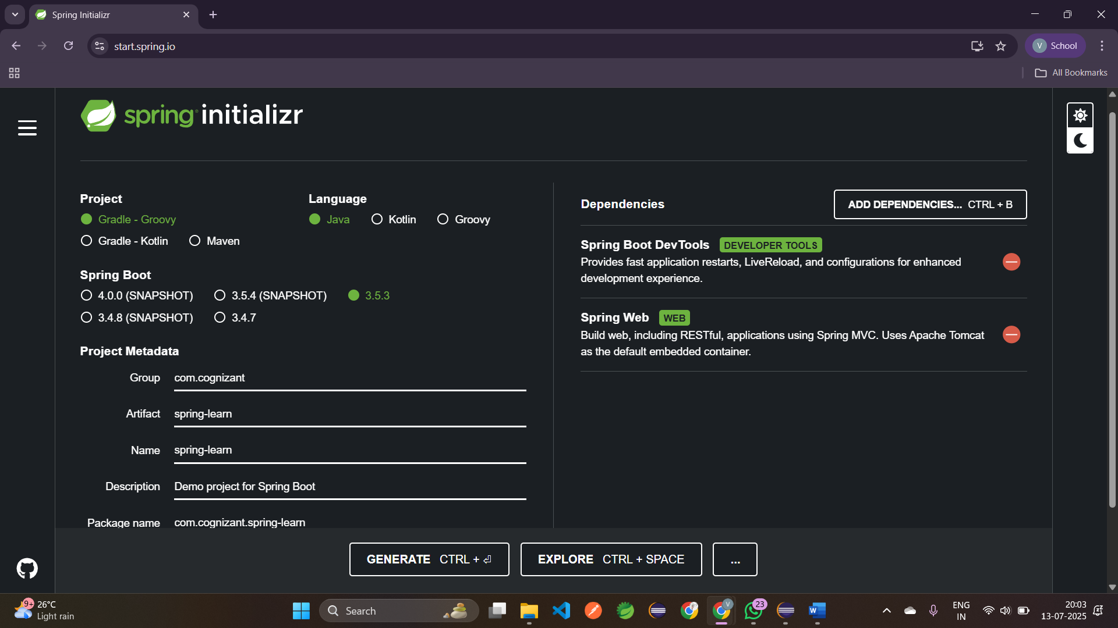  
  
  
Step 2: Import the project in Eclipse

Step 3: Add Logging to verify if main() method of SpringLearnApplication  
  
 package com.cognizant.spring_learn;  
 import org.slf4j.Logger;  
 import org.slf4j.LoggerFactory;  
 import org.springframework.boot.SpringApplication;  
 import org.springframework.boot.autoconfigure.SpringBootApplication;  
 *@SpringBootApplication* public class SpringLearnApplication {  
 private static final Logger ***LOGGER*** = LoggerFactory.*getLogger*(SpringLearnApplication.class); public static void main(String[] args) {  
 SpringApplication.*run*(SpringLearnApplication.class, args);  
 ***LOGGER***.info("START");  
 ***LOGGER***.info("END");  
 }

}

Output:  
  
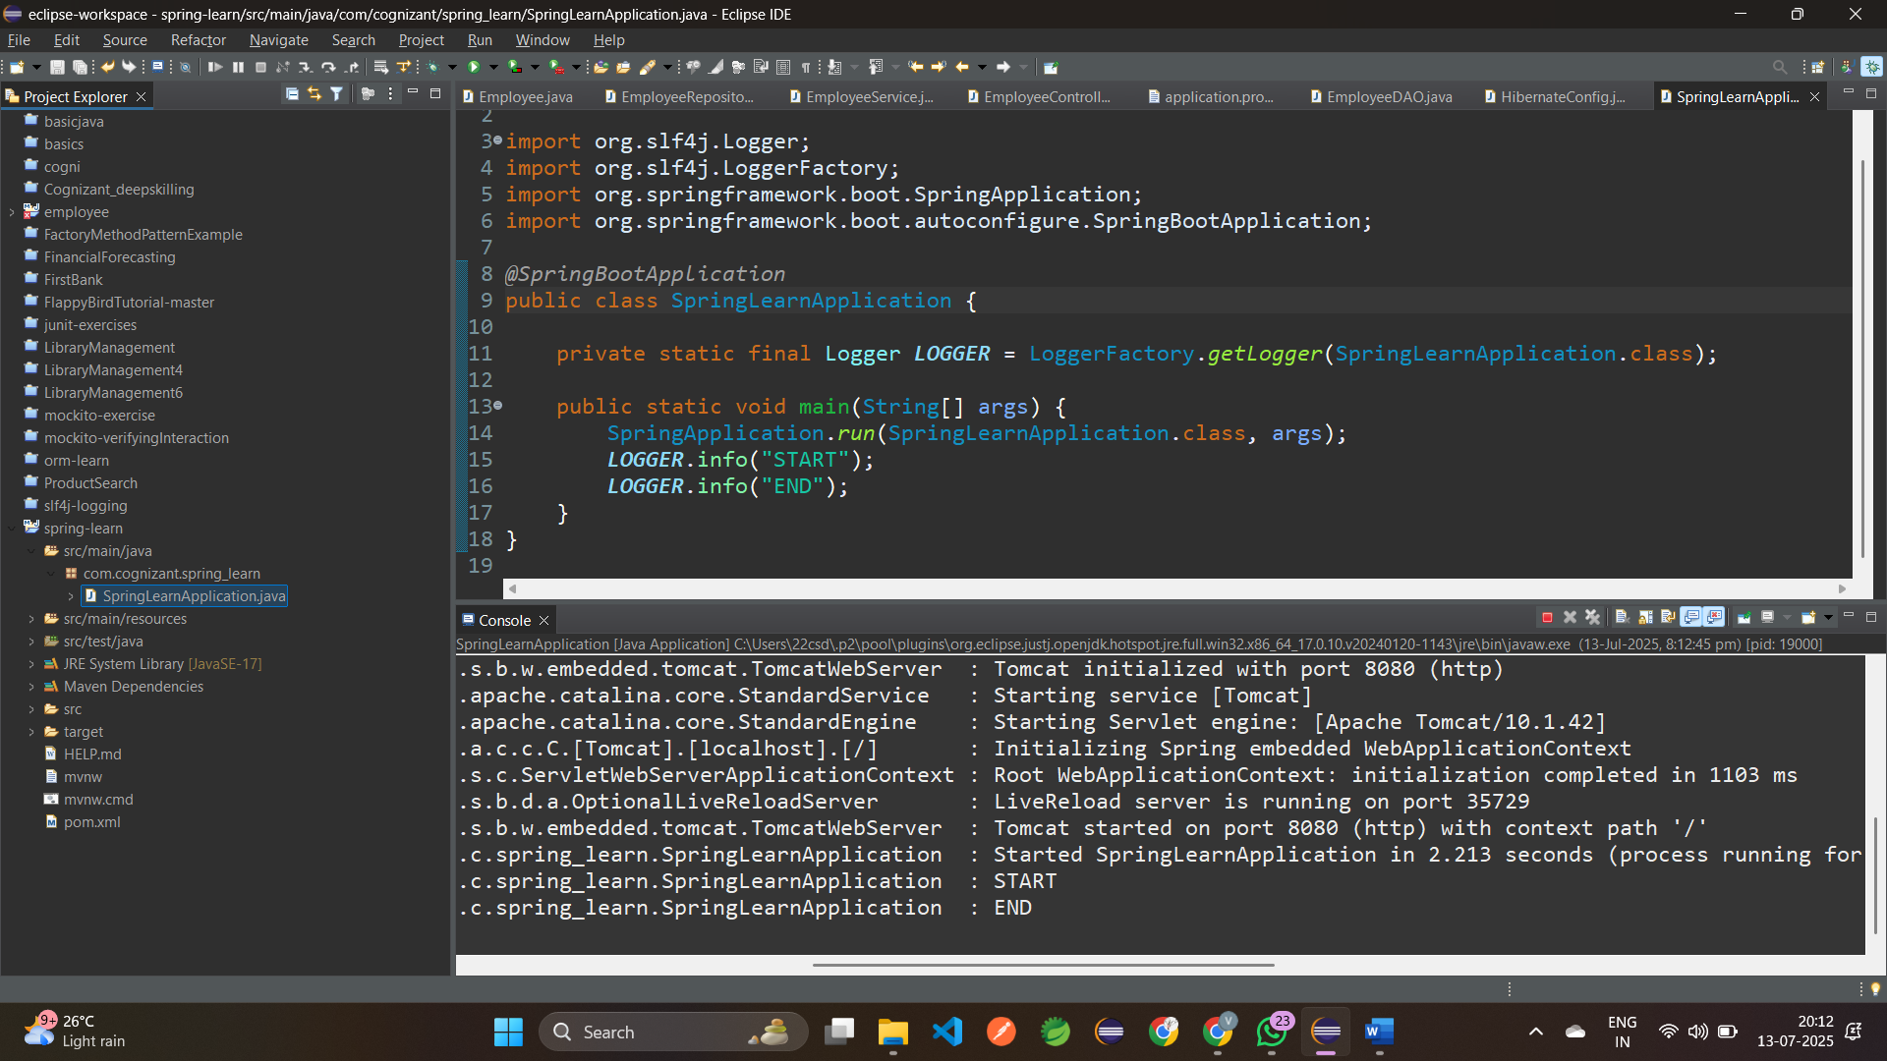  
  
  
  
**Exercise 2: Spring Core – Load SimpleDateFormat from Spring Configuration XML**

Step 1: Creating Spring Configuration file **date-format.xml** in **src/main/resource**

<?xml version="1.0" encoding="UTF-8"?>  
<beans xmlns=<http://www.springframework.org/schema/beans>  
    xmlns:xsi=<http://www.w3.org/2001/XMLSchema-instance>  
    xsi:schemaLocation="http://www.springframework.org/schema/beans  
        https://www.springframework.org/schema/beans/spring-beans.xsd">  
 <bean id="dateFormat" class="java.text.SimpleDateFormat">  
 <constructor-arg value="dd/MM/yyyy" />  
 </bean>  
</beans>

Step 2: Creating **displayDate()** in **SpringLearnApplication.java**

i) Create the ApplicationContext

**ApplicationContext context = new ClassPathXmlApplicationContext("date-format.xml");**

ii) Get the dateFormat using getBean() method

**SimpleDateFormat format = context.getBean("dateFormat", SimpleDateFormat.class);**

**SpringLearnApplication.java**  
  
package com.cognizant.spring_learn;  
import java.text.SimpleDateFormat;  
import java.util.Date;  
import org.springframework.context.ApplicationContext;  
import org.springframework.context.support.ClassPathXmlApplicationContext;  
import org.springframework.boot.SpringApplication;  
import org.springframework.boot.autoconfigure.SpringBootApplication;  
*@SpringBootApplication*public class SpringLearnApplication {  
 //private static final Logger LOGGER = LoggerFactory.getLogger(SpringLearnApplication.class); public static void displayDate() {  
 ApplicationContext context = new ClassPathXmlApplicationContext("date-format.xml");  
 SimpleDateFormat format=context.getBean("dateFormat",SimpleDateFormat.class);  
 try {  
 Date parseDate=format.parse("31/12/2018");  
 System.***out***.println("Date: "+parseDate);  
 }catch(Exception e) {  
 e.printStackTrace();  
 }  
 }  
 public static void main(String[] args) {  
 SpringApplication.*run*(SpringLearnApplication.class, args);  
 *displayDate*();  
 //LOGGER.info("START");  
 //LOGGER.info("END");  
 }  
}

iii) Run the Application

Output:

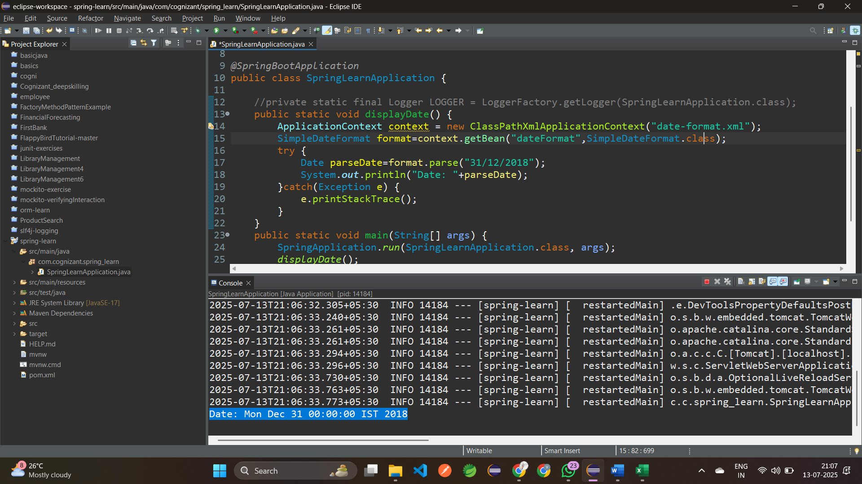

**Exercise 4: Spring Core – Load Country from Spring Configuration XML**

Step 1: Configure country in Spring XML Configuration **country.xml**

<?xml version="1.0" encoding="UTF-8"?>  
 <beans xmlns=<http://www.springframework.org/schema/beans>  
 xmlns:xsi=<http://www.w3.org/2001/XMLSchema-instance>  
 xsi:schemaLocation="http://www.springframework.org/schema/beans  
 https://www.springframework.org/schema/beans/spring-beans.xsd">  
 <bean id="country" class="com.cognizant.spring_learn.Country">  
 <property name="code" value="IN" />  
 <property name="name" value="India" />  
 </bean>  
 </beans>

Step 2: Creating a **Country.java**

package com.cognizant.spring_learn;  
 import org.slf4j.Logger;  
 import org.slf4j.LoggerFactory;  
 public class Country {  
 private static final Logger LOGGER = LoggerFactory.getLogger(SpringLearnApplication.class); private String code;  
 private String name;  
 public Country() {  
 LOGGER.debug("Inside Country Constructor.");  
 }  
 public String getCode() {  
 LOGGER.debug("Getting code");  
 return code;  
 }  
 public void setCode(String code) {  
 LOGGER.debug("Setting code: {}", code);  
 this.code = code;  
 }  
 public String getName() {  
 LOGGER.debug("Getting name");  
 return name;  
 }  
 public void setName(String name) {  
 LOGGER.debug("Setting name: {}", name);  
 this.name = name;  
 }  
 @Override  
 public String toString() {  
 return "Country [code=" + code + ", name=" + name + "]";  
 }}

Step 3: **application.properties**

spring.application.name=spring-learn  
 server.port=8080  
 logging.level.root=DEBUG

Step 4: Create a method **displayCountry()** in **SpringLearnApplication.java** package com.cognizant.spring_learn;  
 import java.text.SimpleDateFormat;  
 import java.util.Date;  
 import org.springframework.context.ApplicationContext;  
 import org.springframework.context.support.ClassPathXmlApplicationContext;  
 import org.slf4j.Logger;  
 import org.slf4j.LoggerFactory;  
 import org.springframework.boot.SpringApplication;  
 import org.springframework.boot.autoconfigure.SpringBootApplication;  
 *@SpringBootApplication* public class SpringLearnApplication {  
 private static final Logger *LOGGER* = LoggerFactory.*getLogger*(SpringLearnApplication.class); public static void displayDate() {  
 ApplicationContext context = new ClassPathXmlApplicationContext("date-format.xml");  
 SimpleDateFormat format=context.getBean("dateFormat",SimpleDateFormat.class);  
 try {  
 Date parseDate=format.parse("31/12/2018");  
 System.*out*.println("Date: "+parseDate);  
 }catch(Exception e) {  
 e.printStackTrace();  
 } }  
 public static void displayCountry() {  
 ApplicationContext context = new ClassPathXmlApplicationContext("country.xml");  
 Country country = context.getBean("country", Country.class);  
 *LOGGER*.debug("Country : {}", country.toString());  
 }  
 public static void main(String[] args) {  
 SpringApplication.*run*(SpringLearnApplication.class, args);  
 *displayDate*();  
 *displayCountry*();  
 //LOGGER.info("START");  
 //LOGGER.info("END");  
 }}

Output:

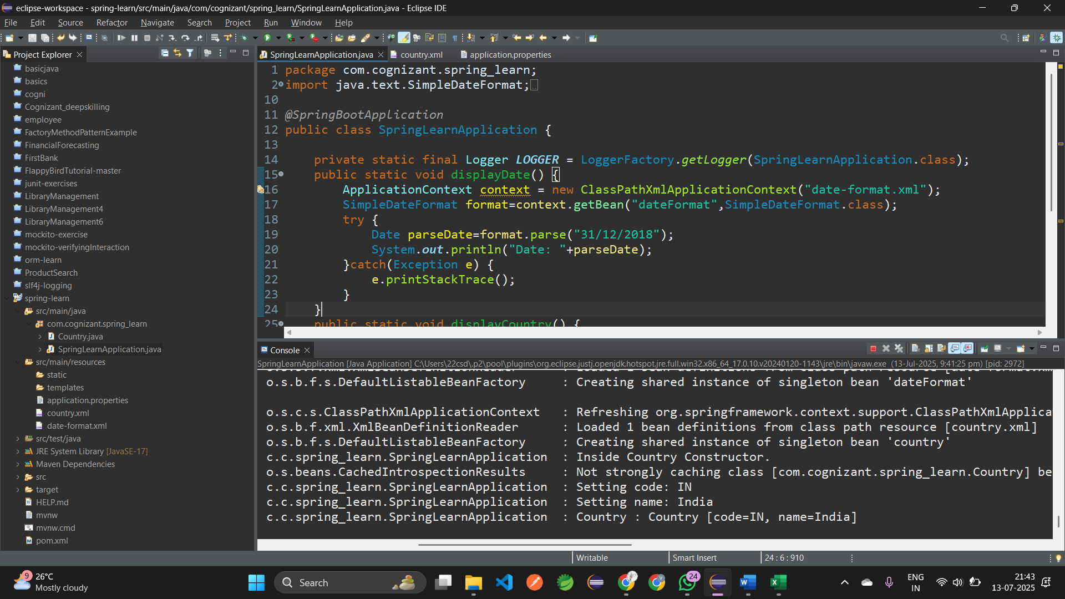

**HandsOn: Hello World RESTful Web Service**Step 1: Creating a **Controller** package**:**  com.cognizant.spring-learn.controller.HelloController

Step 2: Creating a Method **sayHello():**

package com.cognizant.spring_learn.controller;  
import org.slf4j.Logger;  
import org.slf4j.LoggerFactory;  
import org.springframework.web.bind.annotation.GetMapping;  
import org.springframework.web.bind.annotation.RestController;  
*@RestController*public class HelloController {  
 private static final Logger *LOGGER* = LoggerFactory.*getLogger*(HelloController.class);  
 *@GetMapping*("/hello")  
 public String sayHello() {  
 *LOGGER*.info("START - sayHello()");  
 *LOGGER*.info("END - sayHello()");  
 return "Hello World!";  
 }  
}

Step 3: **application.properties:**

spring.application.name=spring-learn  
server.port=7456  
logging.level.root=DEBUG

Step 4: Run **SpringLearnApplication.java:**

package com.cognizant.spring_learn;  
 import java.text.SimpleDateFormat;  
 import java.util.Date;  
 import org.springframework.context.ApplicationContext;  
 import org.springframework.context.support.ClassPathXmlApplicationContext;  
 import org.slf4j.Logger;  
 import org.slf4j.LoggerFactory;  
 import org.springframework.boot.SpringApplication;  
 import org.springframework.boot.autoconfigure.SpringBootApplication;  
 *@SpringBootApplication* public class SpringLearnApplication {  
 private static final Logger *LOGGER* = LoggerFactory.*getLogger*(SpringLearnApplication.class); public static void displayDate() {  
 ApplicationContext context = new ClassPathXmlApplicationContext("date-format.xml");  
 SimpleDateFormat format=context.getBean("dateFormat",SimpleDateFormat.class);  
 try {  
 Date parseDate=format.parse("31/12/2018");  
 System.*out*.println("Date: "+parseDate);  
 }catch(Exception e) {  
 e.printStackTrace();  
 } }  
 public static void displayCountry() {  
 ApplicationContext context = new ClassPathXmlApplicationContext("country.xml");  
 Country country = context.getBean("country", Country.class);  
 *LOGGER*.debug("Country : {}", country.toString());  
 }  
 public static void main(String[] args) {  
 SpringApplication.*run*(SpringLearnApplication.class, args);  
 *displayDate*();  
 *displayCountry*();  
 LOGGER.info("START");  
 LOGGER.info("END");  
 }}

Output:

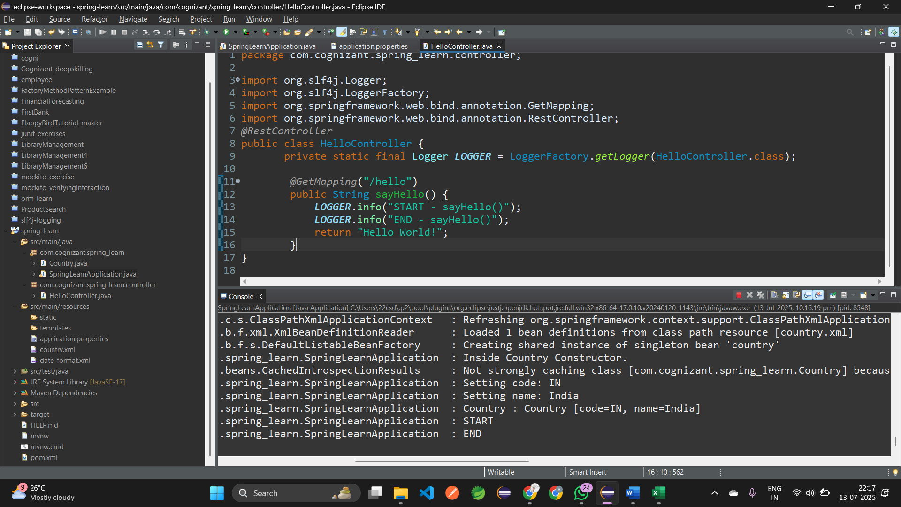

GET Request: <http://localhost:7456/hello>

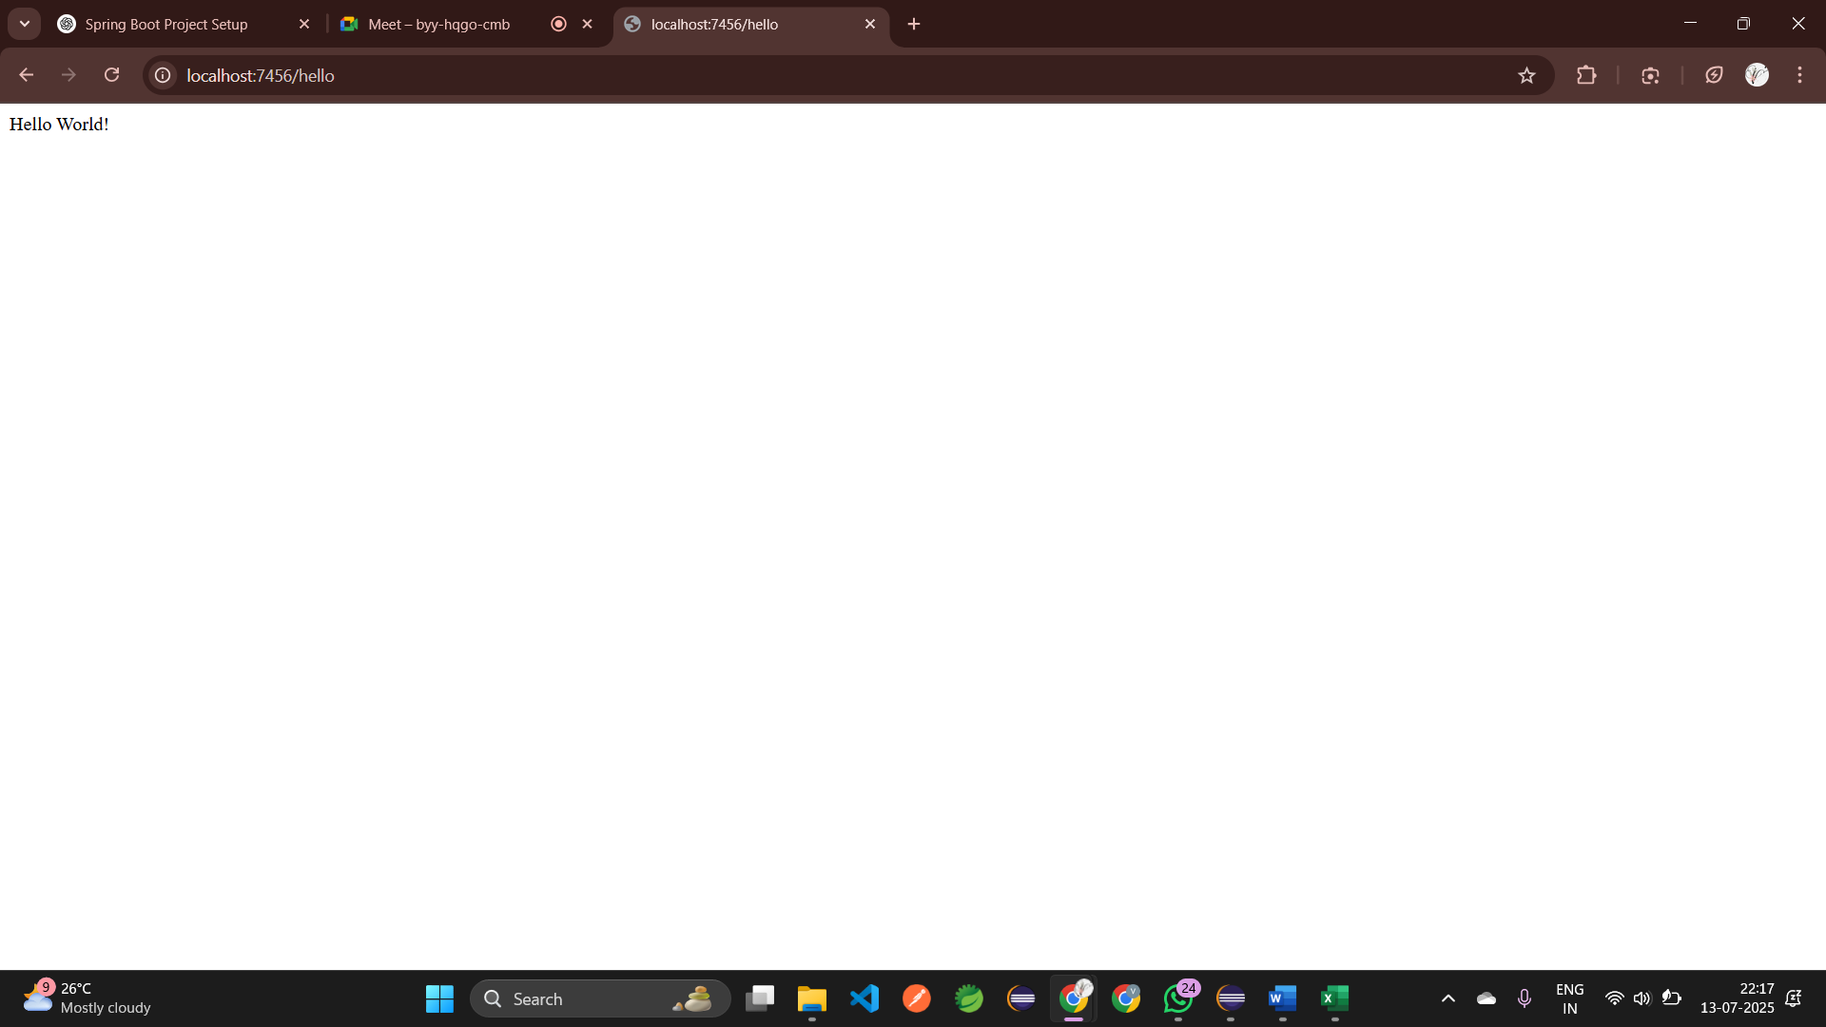

**HANDSON: REST - Country Web Service**

Step 1: Create a **CountryController**:

com.cognizant.spring-learn.controller.CountryController

Step 2: **CountryController.java**

package com.cognizant.spring_learn.controller;

import com.cognizant.spring_learn.Country;

import org.slf4j.Logger;

import org.slf4j.LoggerFactory;

import org.springframework.context.ApplicationContext;

import org.springframework.context.support.ClassPathXmlApplicationContext;

import org.springframework.web.bind.annotation.RequestMapping;

import org.springframework.web.bind.annotation.RestController;

*@RestController*

public class CountryController {

private static final Logger ***LOGGER*** = LoggerFactory.*getLogger*(CountryController.class);

*@RequestMapping*("/country")

public Country getCountryIndia() {

***LOGGER***.info("START - getCountryIndia()");

ApplicationContext context = new ClassPathXmlApplicationContext("country.xml");

Country country = (Country) context.getBean("country", Country.class);

***LOGGER***.debug("Country: {}", country);

***LOGGER***.info("END - getCountryIndia()");

return country;

}

}

Step 3: **application.properties**

spring.application.name=spring-learn  
server.port=8083  
logging.level.root=DEBUG

Step 4: Run the **SpringLearnApplication.java**

package com.cognizant.spring_learn;  
 import java.text.SimpleDateFormat;  
 import java.util.Date;  
 import org.springframework.context.ApplicationContext;  
 import org.springframework.context.support.ClassPathXmlApplicationContext;  
 import org.slf4j.Logger;  
 import org.slf4j.LoggerFactory;  
 import org.springframework.boot.SpringApplication;  
 import org.springframework.boot.autoconfigure.SpringBootApplication;  
 *@SpringBootApplication* public class SpringLearnApplication {  
 private static final Logger *LOGGER* = LoggerFactory.*getLogger*(SpringLearnApplication.class); public static void displayDate() {  
 ApplicationContext context = new ClassPathXmlApplicationContext("date-format.xml");  
 SimpleDateFormat format=context.getBean("dateFormat",SimpleDateFormat.class);  
 try {  
 Date parseDate=format.parse("31/12/2018");  
 System.*out*.println("Date: "+parseDate);  
 }catch(Exception e) {  
 e.printStackTrace();  
 } }  
 public static void displayCountry() {  
 ApplicationContext context = new ClassPathXmlApplicationContext("country.xml");  
 Country country = context.getBean("country", Country.class);  
 *LOGGER*.debug("Country : {}", country.toString());  
 }  
 public static void main(String[] args) {  
 SpringApplication.*run*(SpringLearnApplication.class, args);  
 *displayDate*();  
 *displayCountry*();  
 LOGGER.info("START");  
 LOGGER.info("END");  
 }}

Step 5: **Country.xml** file

<?xml version="1.0" encoding="UTF-8"?>  
 <beans xmlns=<http://www.springframework.org/schema/beans>  
 xmlns:xsi=<http://www.w3.org/2001/XMLSchema-instance>  
 xsi:schemaLocation="http://www.springframework.org/schema/beans  
 https://www.springframework.org/schema/beans/spring-beans.xsd">  
 <bean id="country" class="com.cognizant.spring_learn.Country">  
 <property name="code" value="IN" />  
 <property name="name" value="India" /></bean></beans>

Output:

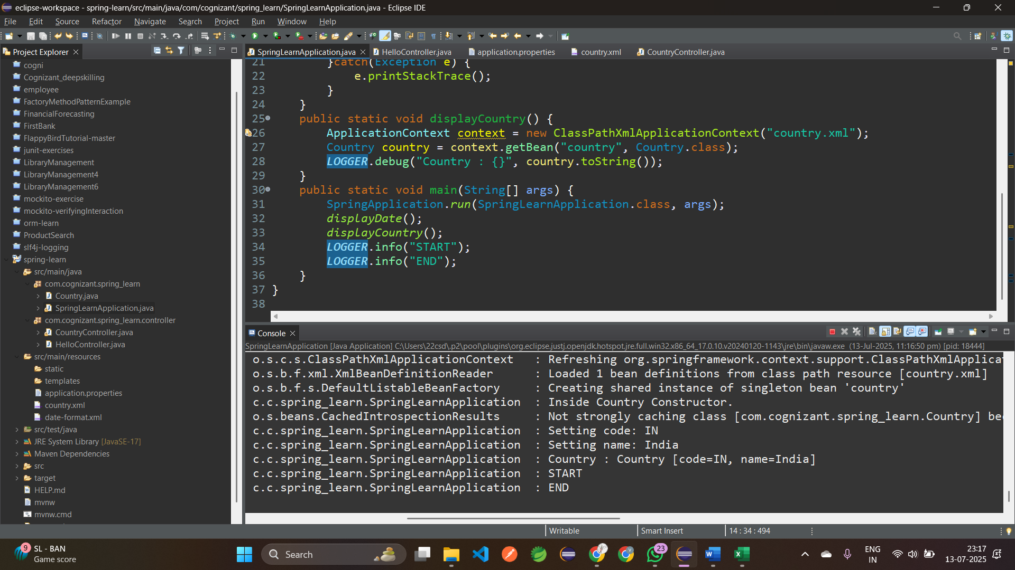

RequestMapping(“/country”) – http://localhost:8083/country

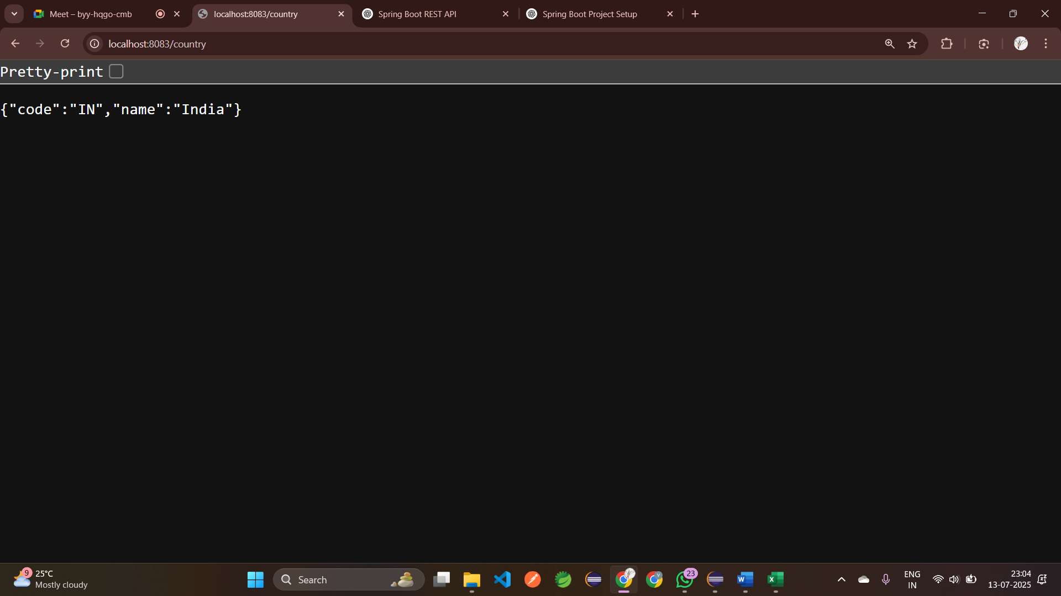

**HANDSON: REST - Get country based on country code**

Step 1: Update **country.xml** to include Multiple Countries:

<?xml version="1.0" encoding="UTF-8"?>  
 <beans xmlns=<http://www.springframework.org/schema/beans>  
 xmlns:xsi=<http://www.w3.org/2001/XMLSchema-instance>  
 xsi:schemaLocation="http://www.springframework.org/schema/beans  
 https://www.springframework.org/schema/beans/spring-beans.xsd">  
 <bean id="country" class="com.cognizant.spring_learn.Country">  
 <property name="code" value="IN" />  
 <property name="name" value="India" />  
 </bean>  
 <bean id="IN" class="com.cognizant.spring_learn.Country">  
 <property name="code" value="IN" />  
 <property name="name" value="India" />  
 </bean>  
 <bean id="US" class="com.cognizant.spring_learn.Country">  
 <property name="code" value="US" />  
 <property name="name" value="United States" />  
 </bean>  
 <bean id="DE" class="com.cognizant.spring_learn.Country">  
 <property name="code" value="DE" />  
 <property name="name" value="Germany" />  
 </bean>  
 <bean id="JP" class="com.cognizant.spring_learn.Country">  
 <property name="code" value="JP" />  
 <property name="name" value="Japan" />  
 </bean>  
 <bean id="countryList" class="java.util.ArrayList">  
 <constructor-arg>  
 <list>  
 <ref bean="IN"/>  
 <ref bean="US"/>  
 <ref bean="DE"/>  
 <ref bean="JP"/>  
 </list>  
 </constructor-arg>  
 </bean>  
 </beans>

Step 2: Update **CountryController.java**

package com.cognizant.spring_learn.controller;  
 import org.springframework.beans.factory.annotation.Autowired;  
 import org.springframework.context.ApplicationContext;  
 import org.springframework.context.support.ClassPathXmlApplicationContext;  
 import org.slf4j.Logger;  
 import org.slf4j.LoggerFactory;  
 import org.springframework.web.bind.annotation.GetMapping;  
 import org.springframework.web.bind.annotation.PathVariable;  
 import org.springframework.web.bind.annotation.RequestMapping;  
 import org.springframework.web.bind.annotation.RestController;

import com.cognizant.spring_learn.Country;  
*@RestController*public class CountryController {  
 private static final Logger *LOGGER* = LoggerFactory.*getLogger*(CountryController.class);  
 *@Autowired* private CountryService countryService;  
 *@GetMapping*("/country/{code}")  
 public Country getCountry(*@PathVariable* String code) {  
 *LOGGER*.info("START - getCountry({})", code);  
 Country country = countryService.getCountry(code);  
 *LOGGER*.debug("Country: {}", country);  
 *LOGGER*.info("END - getCountry()");  
 return country;  
 }  
}

Step 3: Create a **CountryService** class in **com.cognizant.springlearn.service/CountryService.java**

package com.cognizant.spring_learn.controller;  
 import com.cognizant.spring_learn.Country;  
 import org.springframework.context.ApplicationContext;  
 import org.springframework.context.support.ClassPathXmlApplicationContext;  
 import org.springframework.stereotype.Service;  
 import java.util.List;  
 *@Service* public class CountryService {  
 public Country getCountry(String code) {  
 ApplicationContext context = new ClassPathXmlApplicationContext("country.xml");  
 List<Country> countries = (List<Country>) context.getBean("countryList");  
 return countries.stream()  
 .filter(c -> c.getCode().equalsIgnoreCase(code))  
 .findFirst()  
 .orElse(null);  
 }}

Step 4: Run **SpringLearnApplication.java:** package com.cognizant.spring_learn;  
 import java.text.SimpleDateFormat;  
 import java.util.Date;  
 import org.springframework.context.ApplicationContext;  
 import org.springframework.context.support.ClassPathXmlApplicationContext;  
 import org.slf4j.Logger;  
 import org.slf4j.LoggerFactory;  
 import org.springframework.boot.SpringApplication;  
 import org.springframework.boot.autoconfigure.SpringBootApplication;  
 *@SpringBootApplication* public class SpringLearnApplication {  
 private static final Logger *LOGGER* = LoggerFactory.*getLogger*(SpringLearnApplication.class); public static void displayDate() {  
 ApplicationContext context = new ClassPathXmlApplicationContext("date-format.xml");  
 SimpleDateFormat format=context.getBean("dateFormat",SimpleDateFormat.class);  
 try {  
 Date parseDate=format.parse("31/12/2018");  
 System.*out*.println("Date: "+parseDate);  
 }catch(Exception e) {  
 e.printStackTrace();  
 } }  
 public static void displayCountry() {  
 ApplicationContext context = new ClassPathXmlApplicationContext("country.xml");  
 Country country = context.getBean("country", Country.class);  
 *LOGGER*.debug("Country : {}", country.toString());  
 }  
 public static void main(String[] args) {  
 SpringApplication.*run*(SpringLearnApplication.class, args);  
 *displayDate*();  
 *displayCountry*();  
 LOGGER.info("START");  
 LOGGER.info("END");  
 }}

Output:

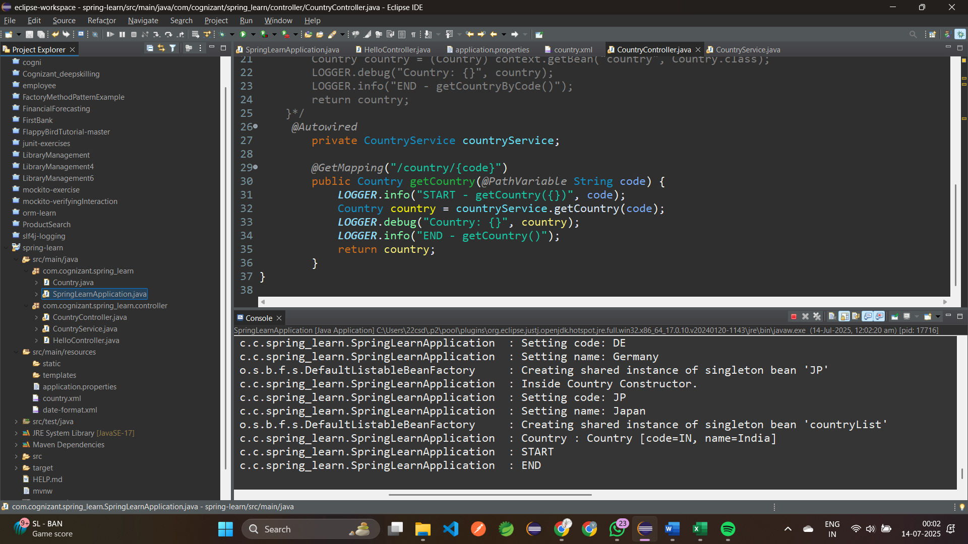

* Step 5: Open Browser <http://localhost:8083/country/US>

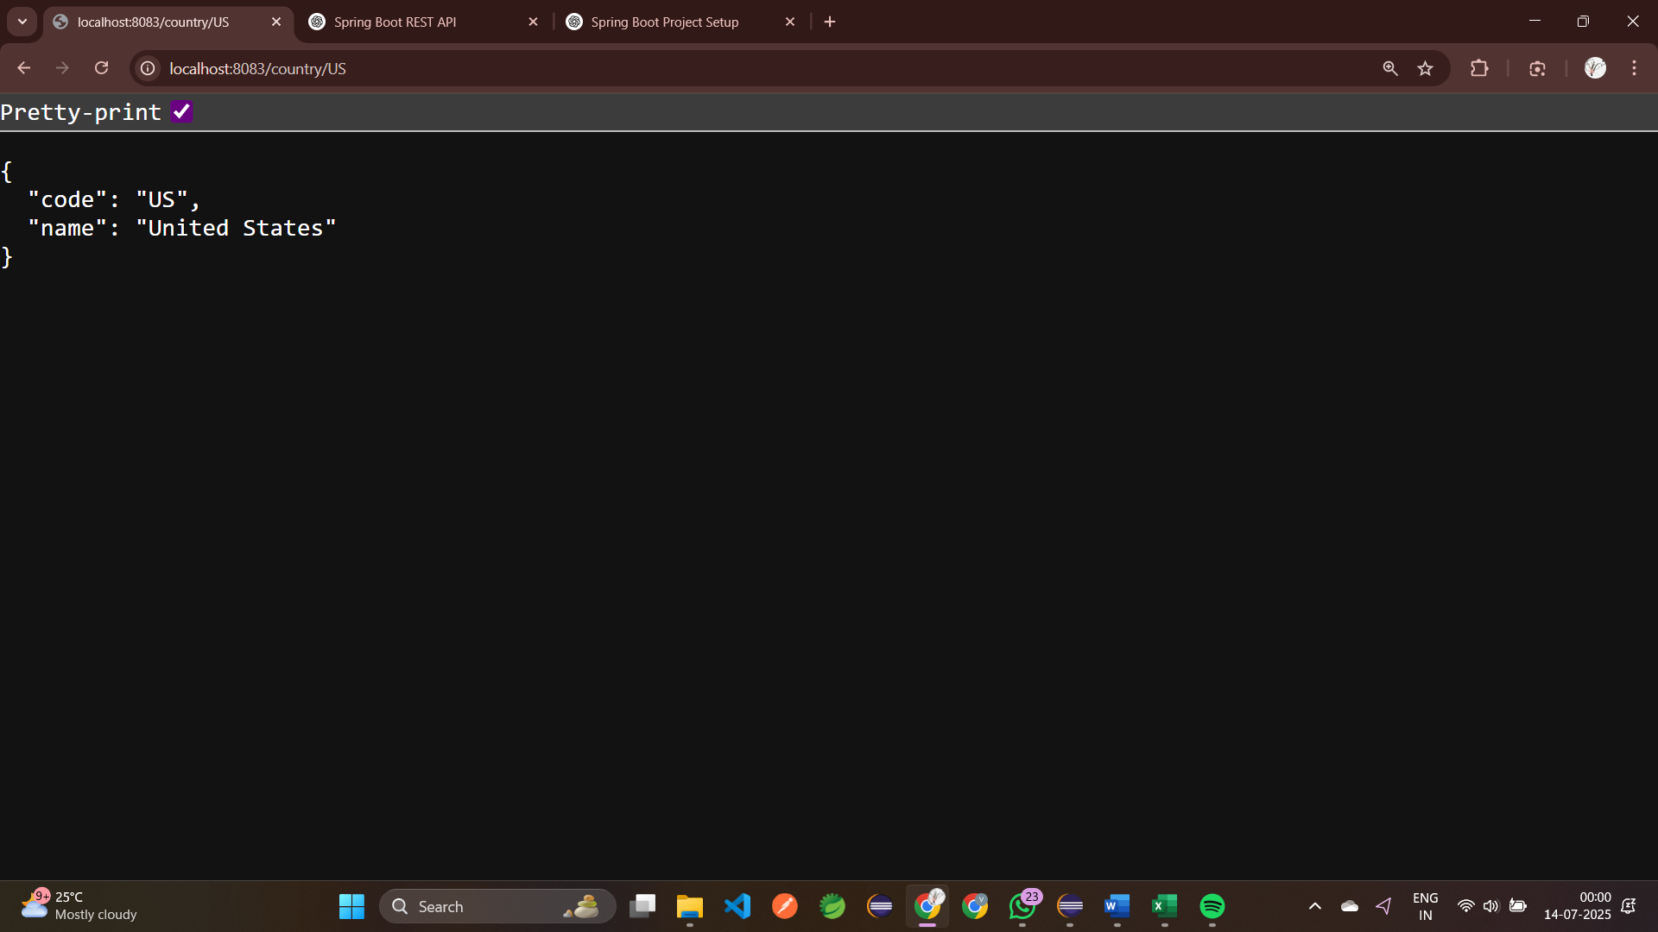

* Step 6: <http://localhost:8083/country/DE>  
    
  